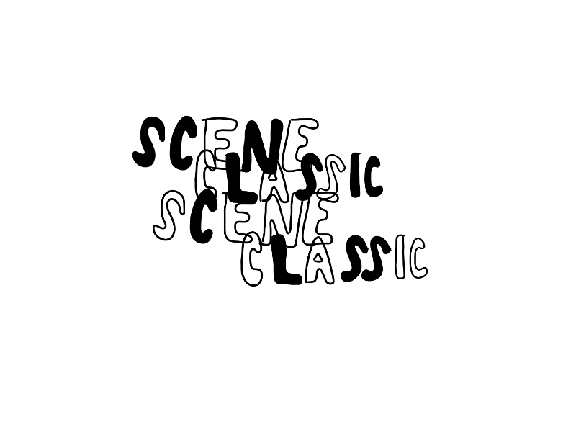

*Scene Classic is a zine series about albums I’ve decided, for whatever reason, are scene classics and then I talk about them.*

*#3*



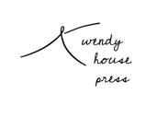

*a zine by miranda reinert*

*When I first heard Home Like Noplace Is There it was unlike anything I was listening to. Like most albums in this zine series, I listened to it because I saw something on tumblr all the time. The house imagery was everywhere and I was drawn to it. I was also drawn to the lyrics people chose to write under the audio posts, even though the audio itself never worked anyway.*

*I liked it in 2014 for many of the same reasons I like it now, despite not just seeking out sad music because I was sad. It’s dense, but it doesn’t feel long. It’s cathartic. It’s personal and it handles the heavy topics in a way that never made me feel bad the way some emotionally charged music does. It felt necessary, it still feels necessary. That sense is why I’m confident it’ll survive as one of the emo revival albums to remember.*

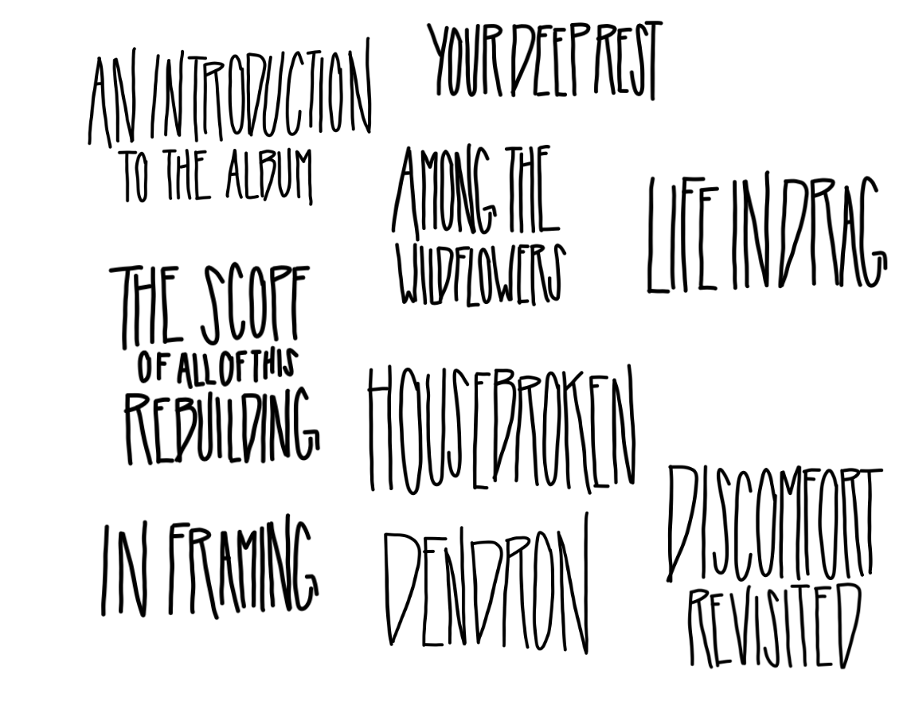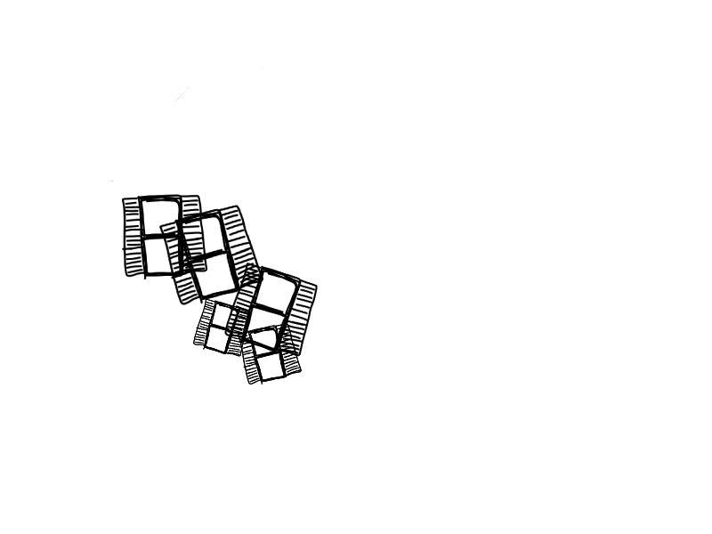

*This is one of my favorite opening tracks. It intricately spins through priming the album to follow. All of the imagery hits me just right: curtains open, electric shorts, guns miss, clothes don’t keep you warm. It all works to build a sparse emotional landscape that crescendos until it falls off instead of fading out. I can’t imagine a better way to start this album.*

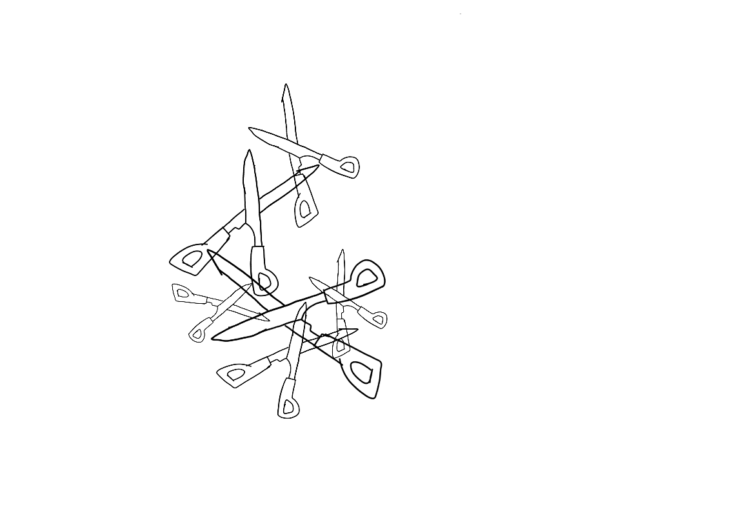

*Much of this album feels like holding on. Holding onto friendship. Holding on when you can’t see it getting better. Holding on through all kinds of loss. This song, in all of its many lyrics, marries that feeling with hopelessness and stress in a way that always resonated with me.*

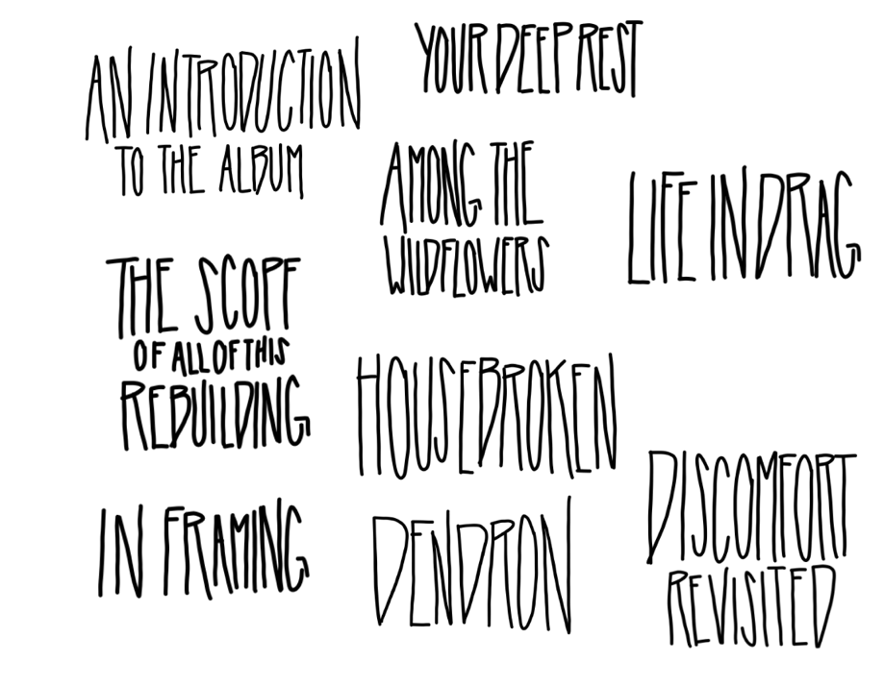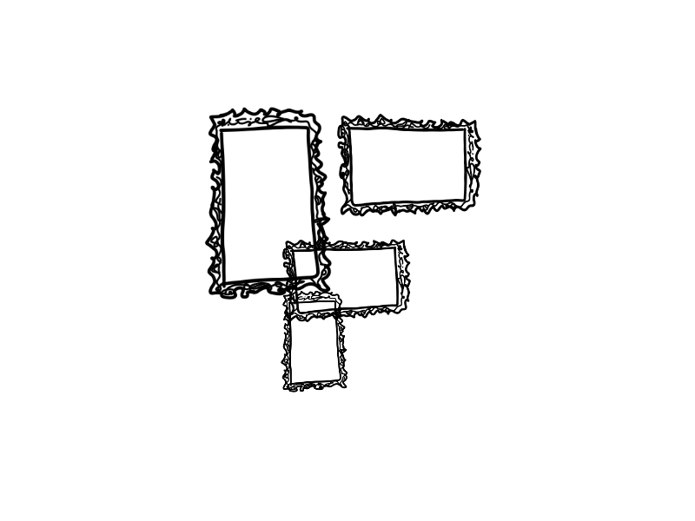

*This is my personal favorite song on the album. On an album full of catharsis, this is the one that feels the most cathartic. I like that it’s faster just by nature of my general taste but it also has a lot of my favorite lyrics (“You resolve to make your chaos external” HELLO) and moments. The best moment is easily how they slow down and build to just Christian’s voice shouting “called me baby”. Chills. It might be one of my favorite songs period for that moment alone.*

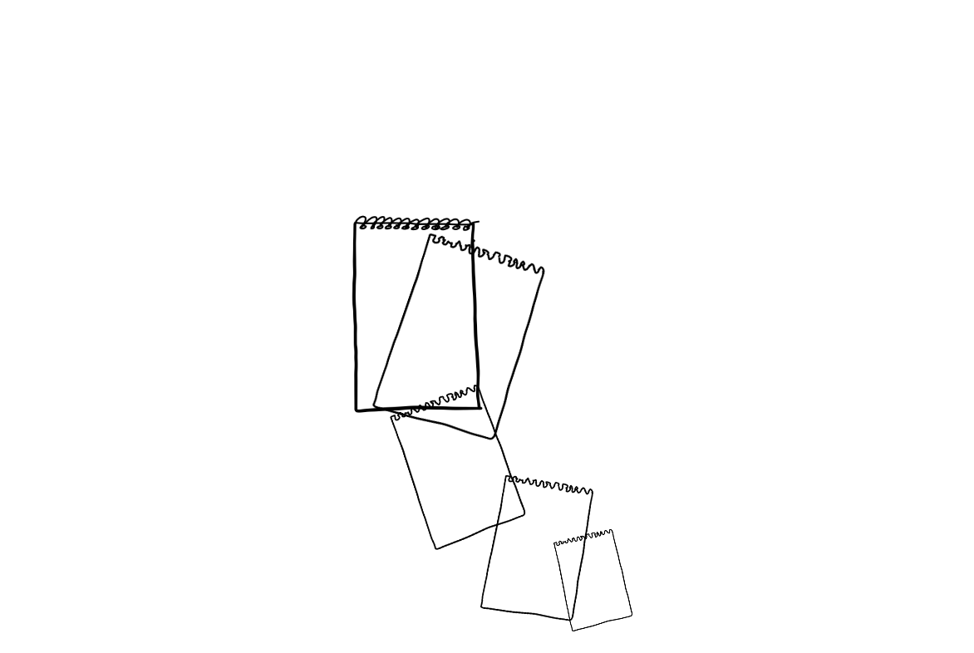

*The thing about this song is that it is what I’ve always thought to be the emotional core of this album but while I listen to it now and try to put in words what I think of it, it’s hard. Obviously it’s devastating. Everything about the song is devastating. The before signs of a suicide to come and the guilt and loss and pain of the aftermath. As a person who has spent a lot of time intimately relating to a lot of what’s said, it’s effective. Despite that, I want to say more than it’s a painful listen because I have the impulse to defend most sad music I love as more than just that. I think this album is more than that. But I guess it’s okay to let it be and let this song play that role.*

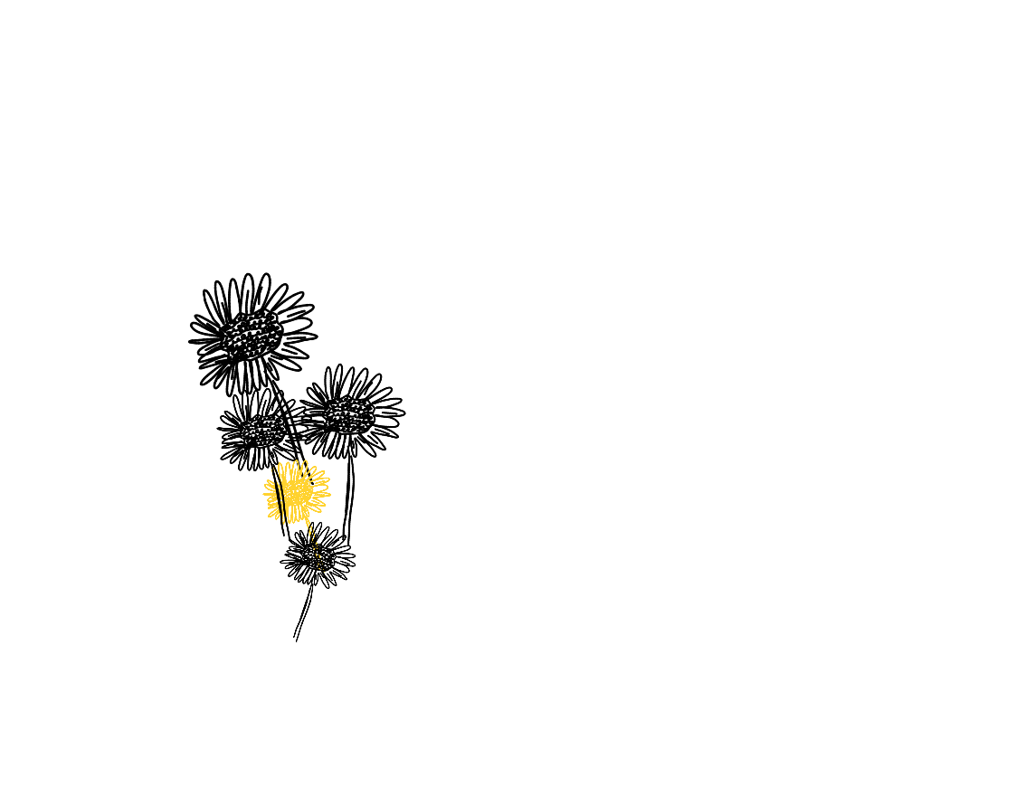

*This, despite not being my favorite song, feels suitable in following to Your Deep Rest. I always liked the line “you came out started losing / find it tough to admit when you’re losing” and how it carries the themes of the song. The escalation into shouting feels like an inevitable and important aspect of the record (and definitely a well worthwhile sonic bridge between Your Deep Rest and Life in Drag). I appreciate that the end introduces a level of naivety in protecting people you care about that the album, on the whole, doesn’t have. It’s impeccably placed and vital, regardless of my personal inclination.*



*The times Christian Holden has discussed gender have been fascinating and honest in how complex one’s relationship to their gender can be especially in terms of expression. Life in Drag explores something I don’t necessarily have personal stake in the way I do for much of this record, but I think it’s a vital part of why this album is unique especially in context of the other really popular albums surrounding it at the time. Discussing points of view on gender is so valuable in music that comes from a dominantly male scenes and this song is no exception. It’s also got some wild genius annotations I’d recommend looking at just for fun.*

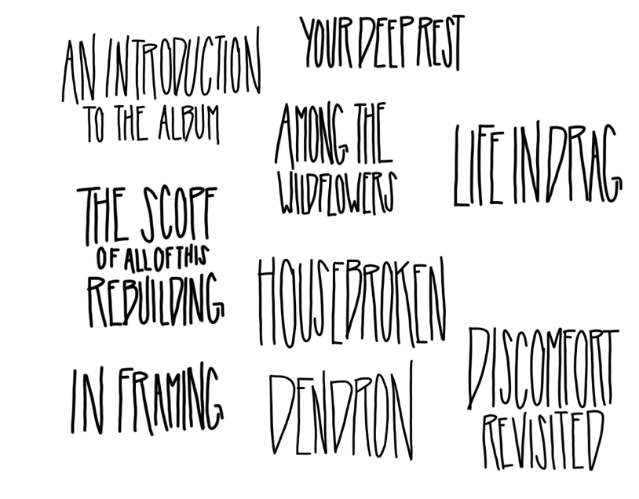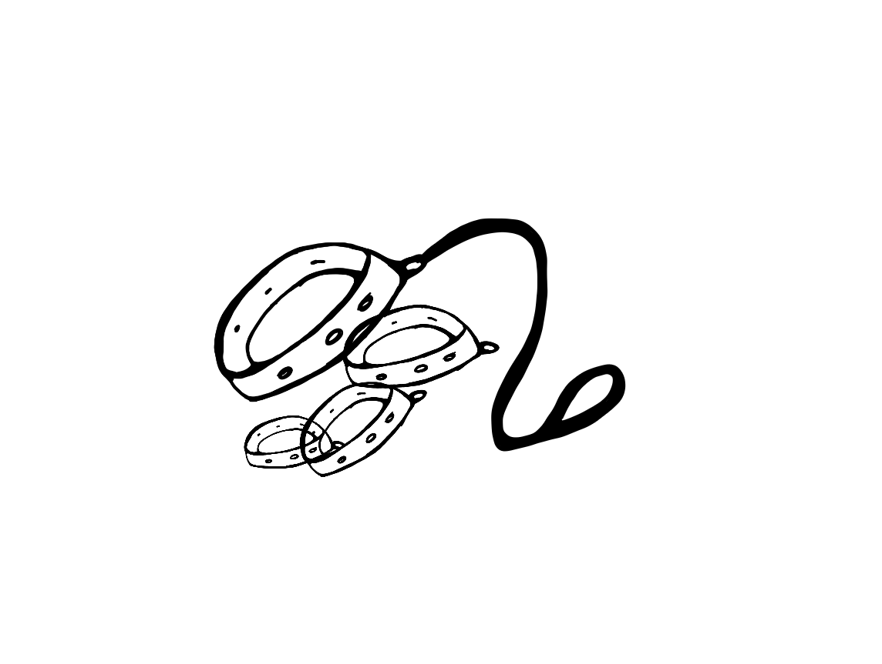

*On some albums I have a favorite song then there’s songs that I actually listen to most. This is that song. Which is saying a lot as I am notorious for implicitly choosing the shortest songs on an album and this one is nearly five minutes. I’ve always taken it as a look at abuse and reactions to it, both in the eyes of those trying to save someone else and the person being abused. I think using dog imagery is an especially effective way to portray fear and uncertainty and lashing out. It’s the only song on this album I’d play for my best friend who tells people I scarred her by showing her King Park by La Dispute in high school.*

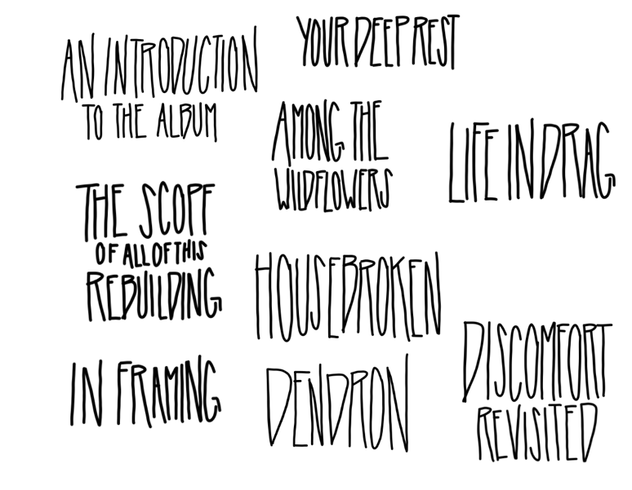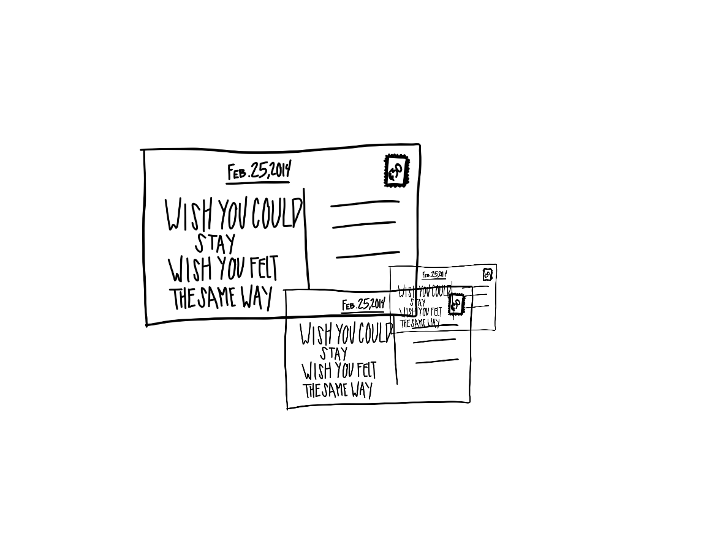

*I hold a lot of residual discomfort with this song. It’s not that it’s all that different in terms of heaviness to the rest of the album, I don’t know what it is. Maybe it’s discussion of medication and illness in a way I don’t personally relate to or like that prevents me from really enjoying what I think are great lyrics in terms of trying to understand the inner workings of someone’s mind. What I will say is that it hit me that I appreciate the way the album works in second person almost always and the discussion on relationships between people who are in tough situations emotionally.*

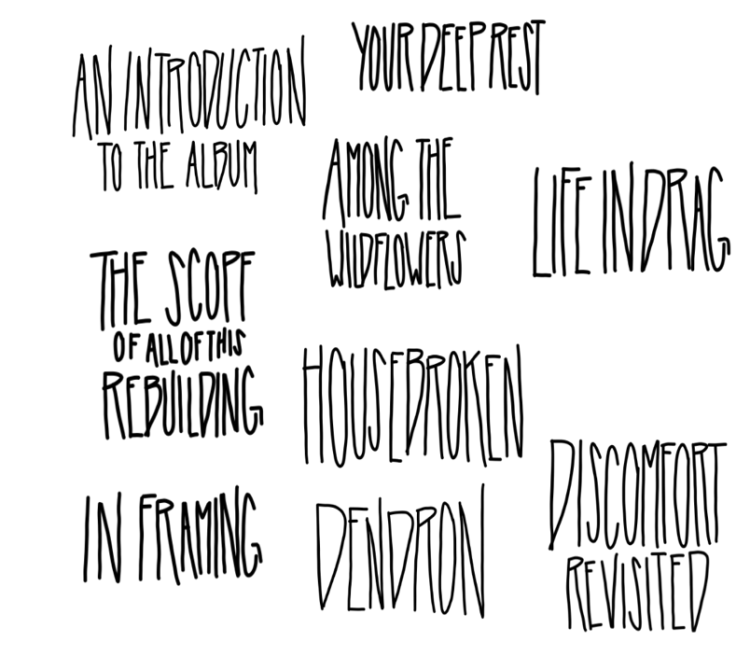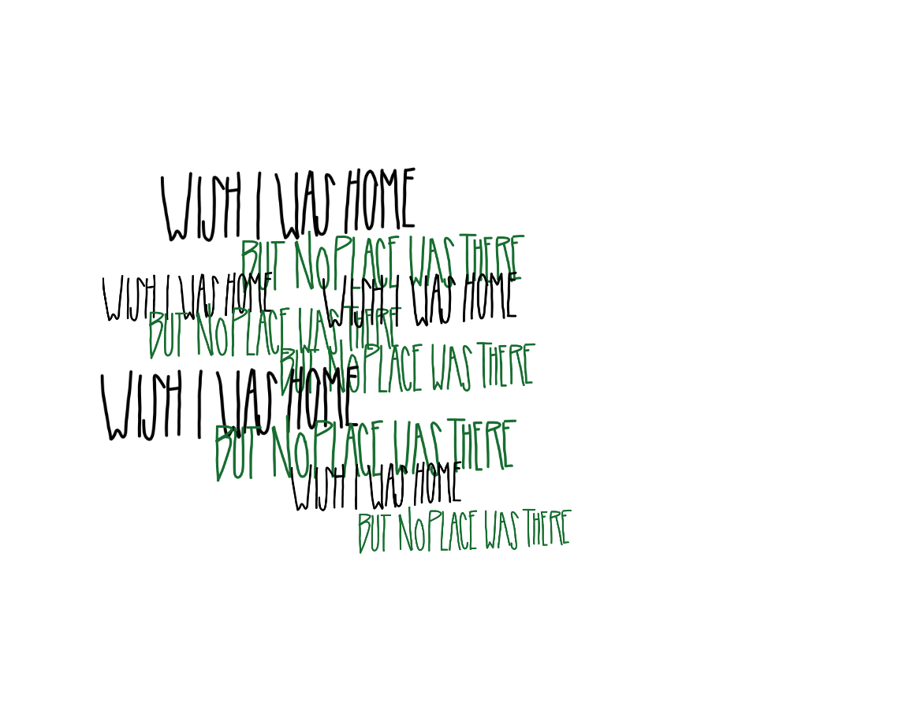

*When I was younger this was my favorite song on the album. I’ll always associate it with a CD I made that I distinctly remember being followed by Match & Tinder by You Blew It! And Gengar! Gengar! Gengar! by Dowsing. It feels the most like me as a teen but I stand by my past self. The album is served well by ending on a song with a lot of heavy house based imagery. It’s also the song that almost says the album title, which I always loved as the title of this album is one of my favorites.*

*this zine was written and illustrated by miranda reinert.*

*thank you.*

*I saw The Hotelier play my senior year of high school with La Dispute and Title Fight a couple days after I got my wisdom teeth out and because I couldn’t move my mouth much, I couldn’t sing along. As a result, all I remember from that night is being hit with an album I already knew intimately in an entirely new way and staring at Christian Holden in awe.*

*I was severely depressed when this album first impacted me, but what lasts is not a memory of how horrible I felt then. It’s the feeling of disbelief and awe.*

whp3



*Scene Classic is a zine series about albums I’ve decided, for whatever reason, are scene classics and then I talk about them.*

*#3*