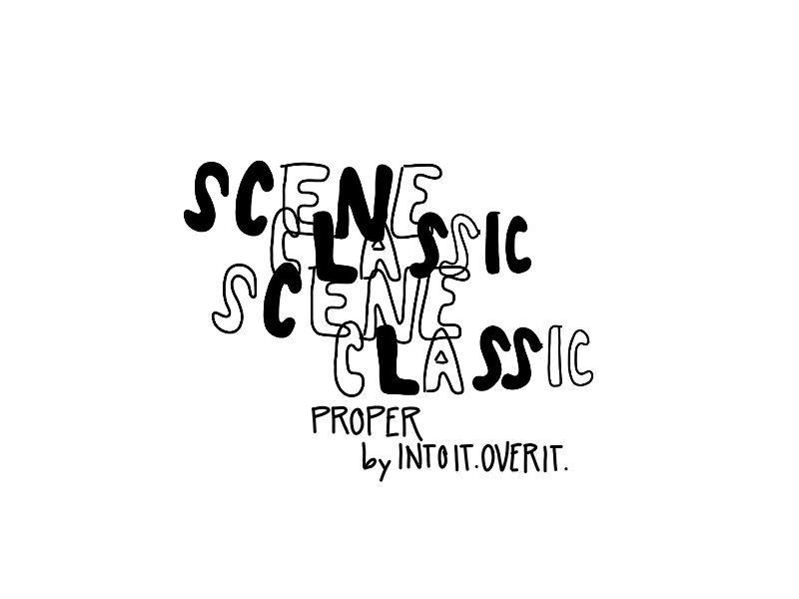

*a zine by miranda reinert*

*Scene Classic is a zine series about albums I’ve decided, for whatever reason, are scene classics and then I talk about them.*

*#1*

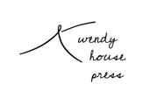

*The first time I ever heard of Into it. Over it. I was probably 16 watching a sort of “musicians interview each other” style video with Evan Weiss and Dan Campbell from The Wonder Years. Then, through the magic of Youtube recommended videos, found The Wonder Years covering Anchor then Into it. Over it. covering Don’t Let Me Cave In. I watched the IIOI version of Anchor and later heard Pinky Swear on a tumblr audio post and was sold… but 52 Weeks is long so I went with listening to Proper instead.*

*And I’ll just say it.. Listening to it changed my life. From silly things like my high school boyfriend writing “needed a proper way to ask you out” on the copy of it I still use, to the people I’ve met through it, to it triggering me to learn about music outside of pop punk that informs a lot of my taste.*

*I don’t know how to write about music but I do love this album & it starts with a song I put on every playlist from ages 16 to 19..*

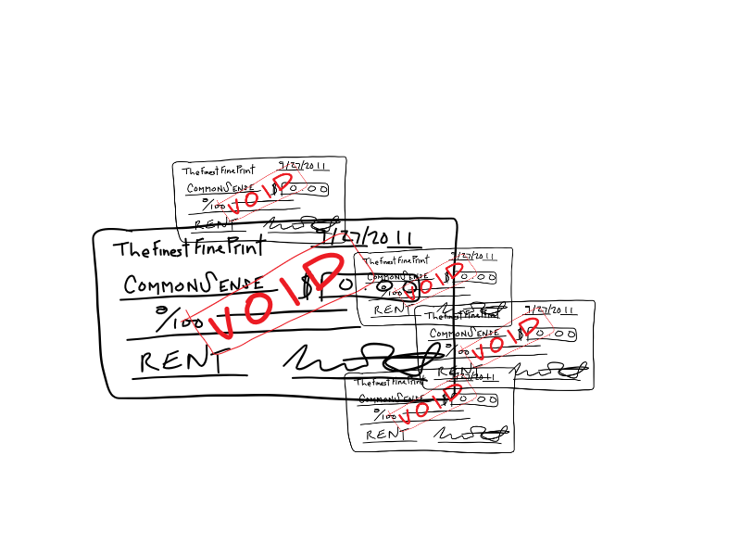

*This song starts with “how the hell could I have been so dumb?” and employs a technique of repeating a line save for one changed word that is present in a lot of Evan Weiss’s songwriting. Self-reflection on a past version of yourself: dumb and weak, but also makes a pseudo chorus through line for the song. It’s a song I’ve always taken to be looking back on your past mistakes and recognizing actions you’re less than proud of, but also being honest with yourself about the ways that person is still you.*

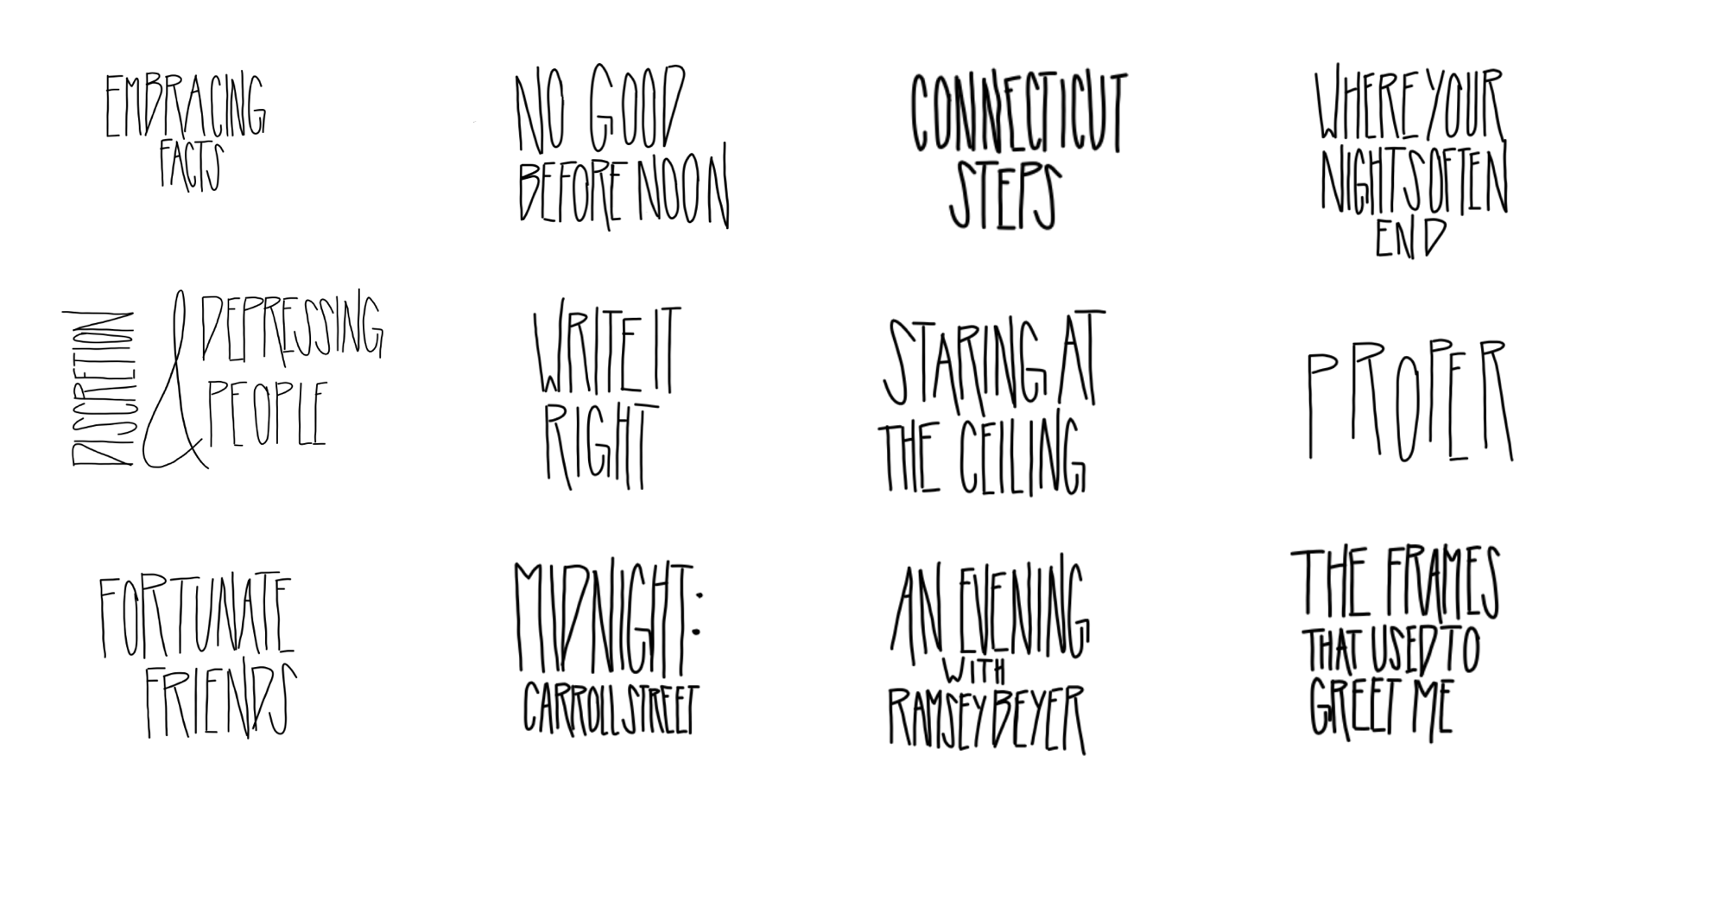

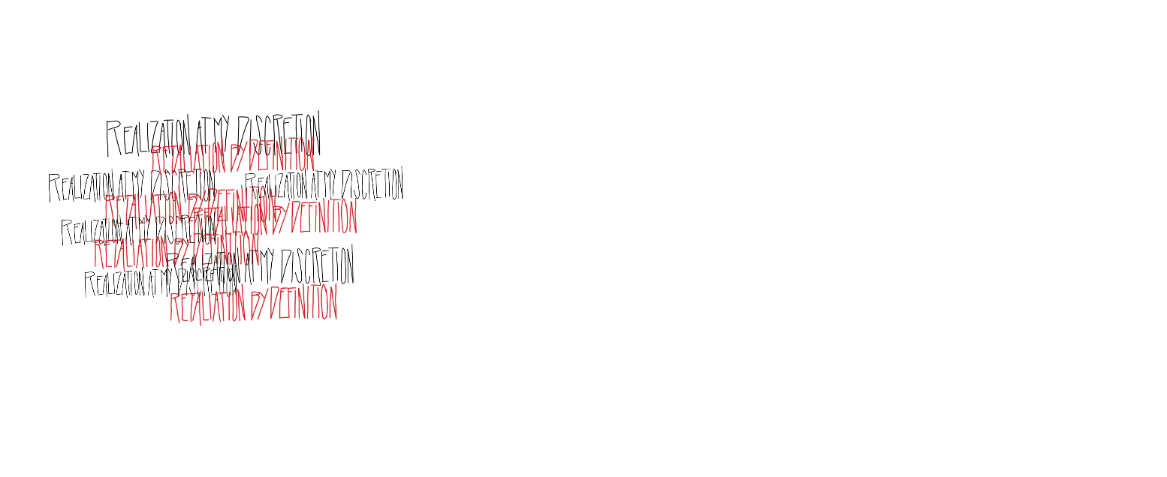

*This is my favorite song on this album (with a very similar title to my favorite Stay Ahead of the Weather track). It’s the best version of reflexive language used throughout the album; sharp and distinct in its condemnation. “Your lack of confidence is not a right to verbally abuse” is a line that has stuck with me for years. It’s a line to point at someone else but also at myself when I find myself being shittier than I’d like during a period of insecurity (Which I am prone to doing. All we can do is work on ourselves, right?)*

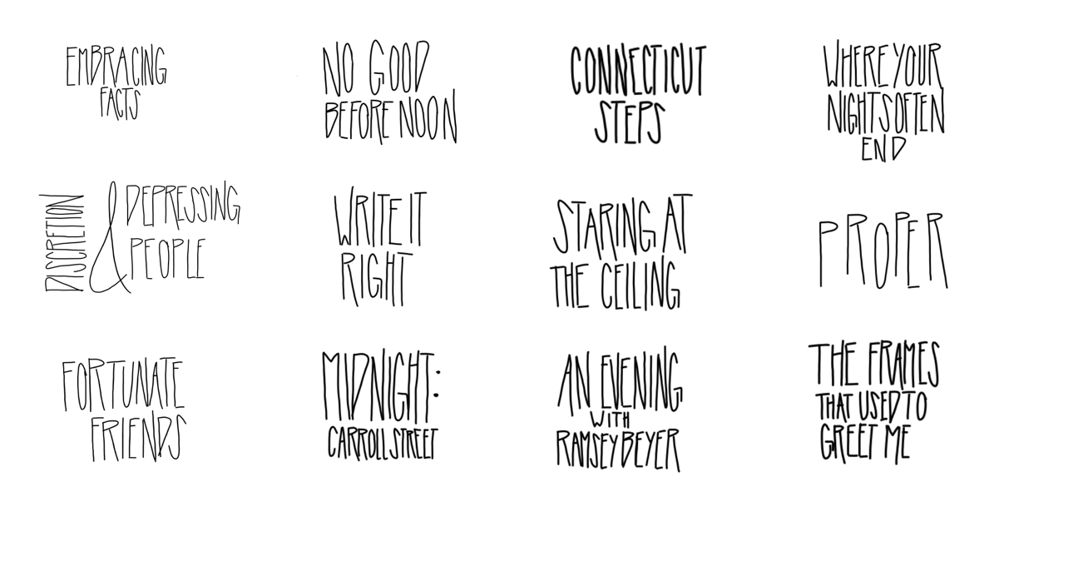

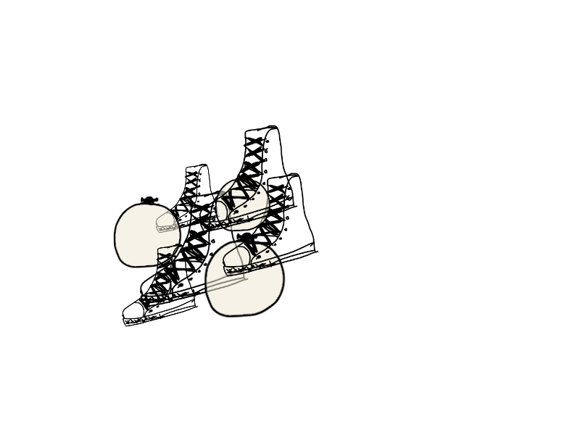

*Fortunate Friends isn’t a song I ever thought too much about until finding something relatable in discussing existing in arts centered circles. Now lines like “passing credentials through a status you’ve assumed” hit me differently. But on this song, and several others, the voice of 20-something authenticity based superiority comes through to me heavy and it’s mostly funny. Something to prove indeed.*

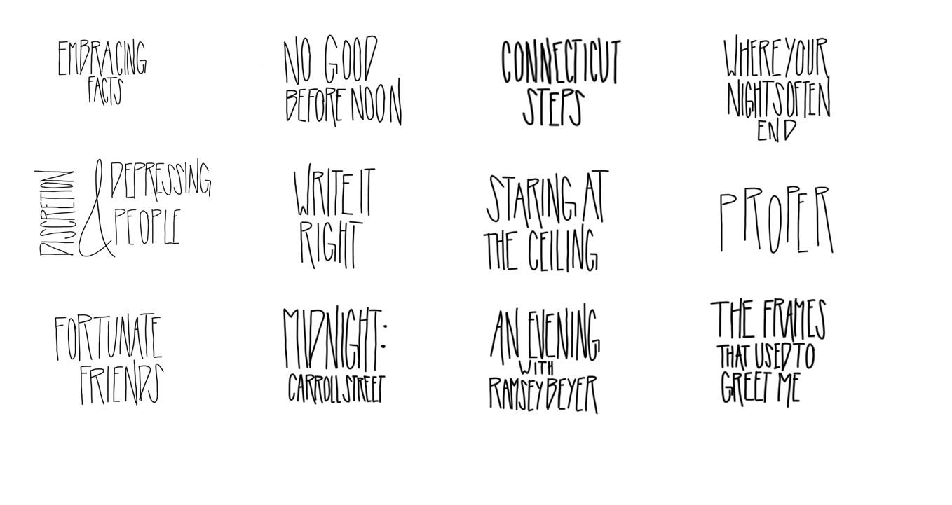



*A pleasant break and a song I hold dear. Not just because I, too, am no good before noon. But also because it’s akin to the newer Into it. Over it. feeling a non-teenage version of myself finds comforting. It’s warm. It feels like staying in bed on a winter morning or riding public transit on a fall afternoon. I have nothing analytical to say.*

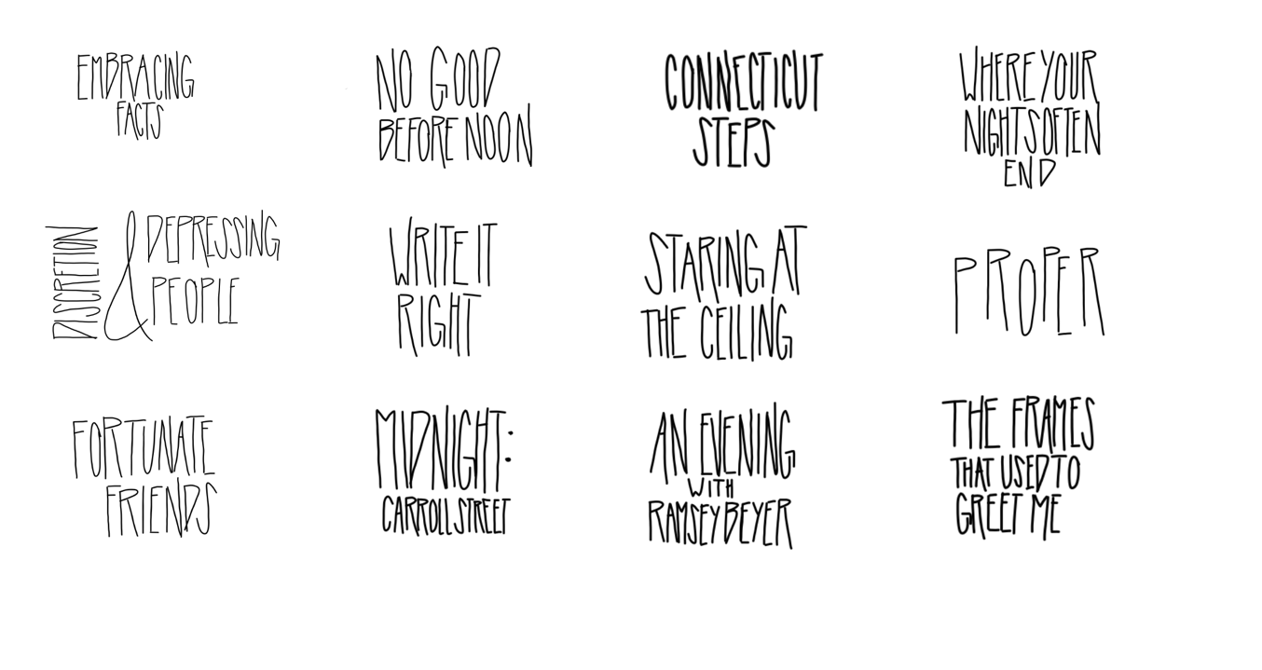

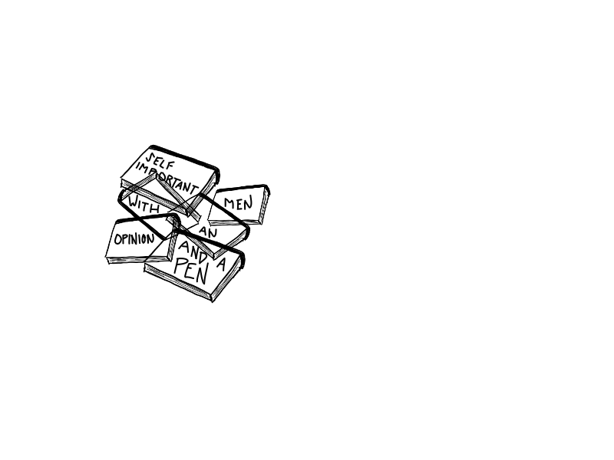

*We are back to songs that read like me and my friends talking at a bad art school party. Same energy as Discretion, but lighter with more humor. The writing motif just keeps getting better as the song goes on and the imagery of “you keep throwing bricks and I’ll pretend you’re building” is one of my favorites on the album. I love a song with a payoff and this one does it. You will never write it right.*

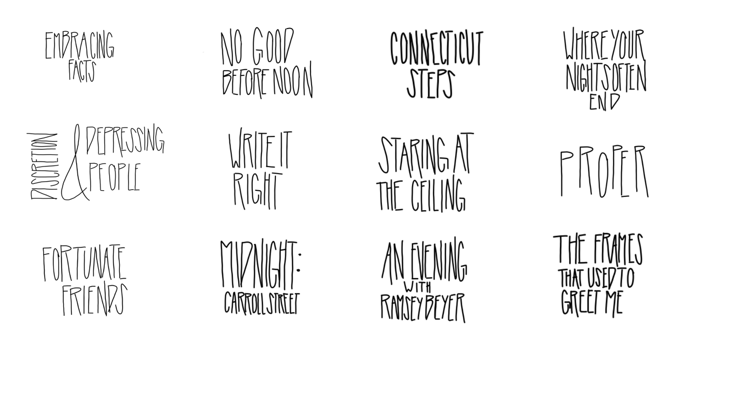

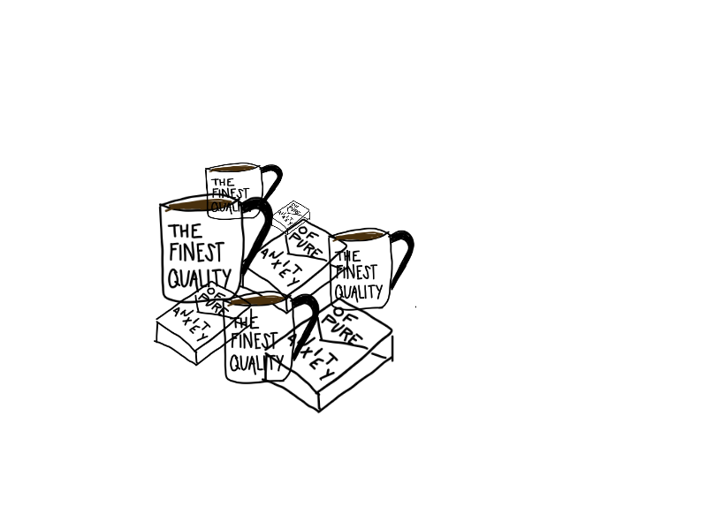

*Heard once the song was intended to start with “cocaine and nicotine” instead of “caffeine and nicotine”. I can’t confirm that for sure because my memory fails me more than it surprises me, but it makes for a biting alternative. The narrative of this song feels like the other side of the coin to the anger of most of this album. Hearing out, hearing at all; calling out, calling at all. A break up song, complexities included.*

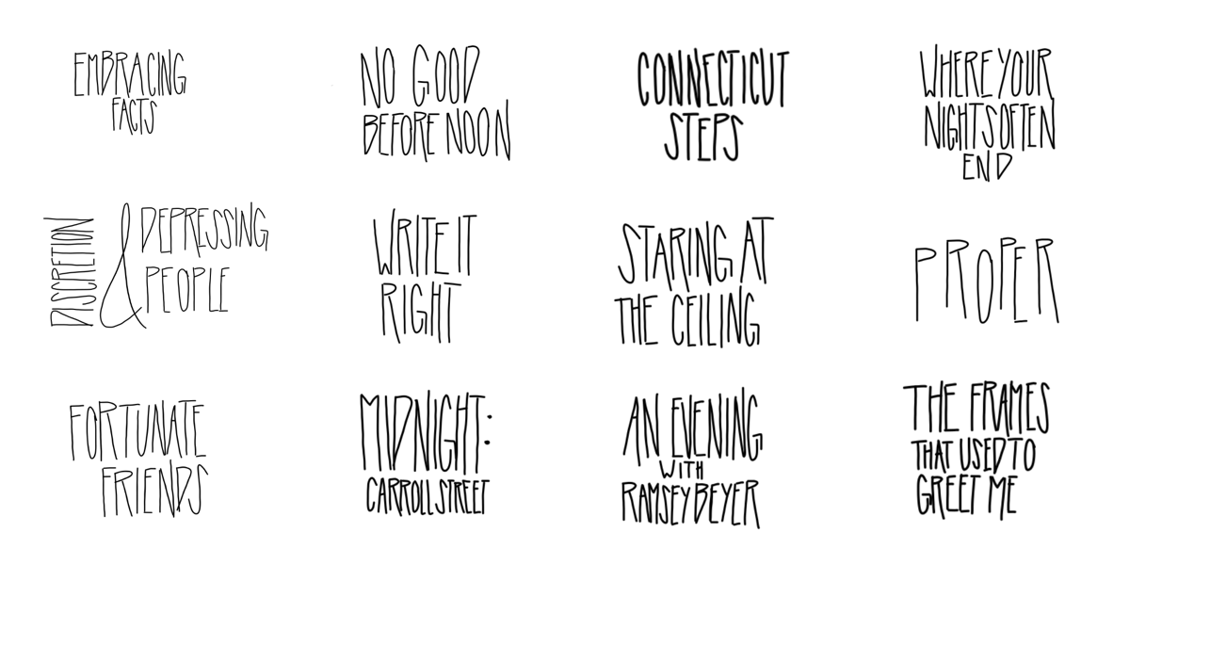



*The description of loss, the ways loss is communicated, and the ways it can’t be is a beautiful achievement of this song. Despite my affinity for The National, I’ve never found myself to gravitate toward really slow, wallowing songs when I’m going through something, so when my grandfather passed a few years back this song was something I rested on. I’m grateful for that.*

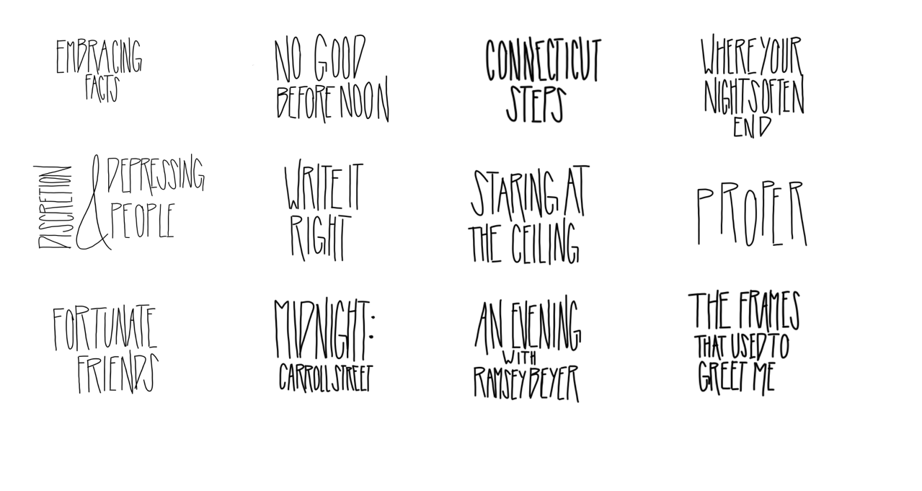

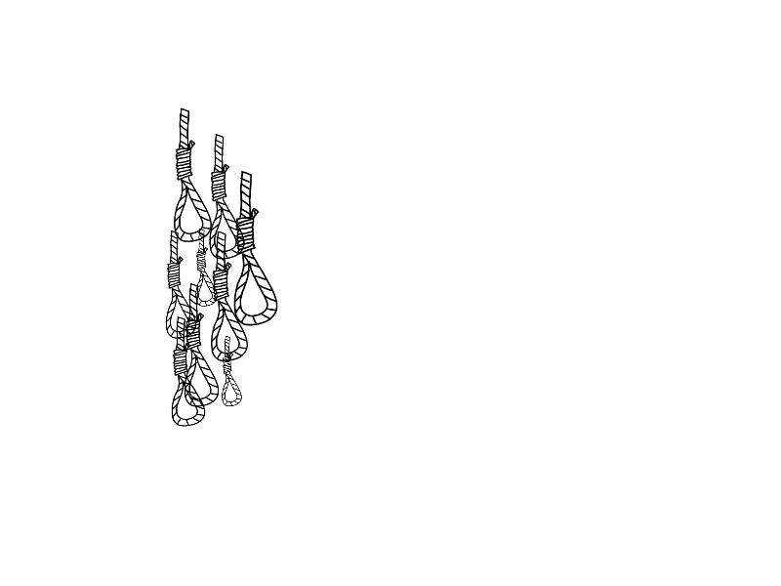

*More quips about inauthenticity. Fuck a fake friend, I suppose, especially if they don’t write their own songs.*

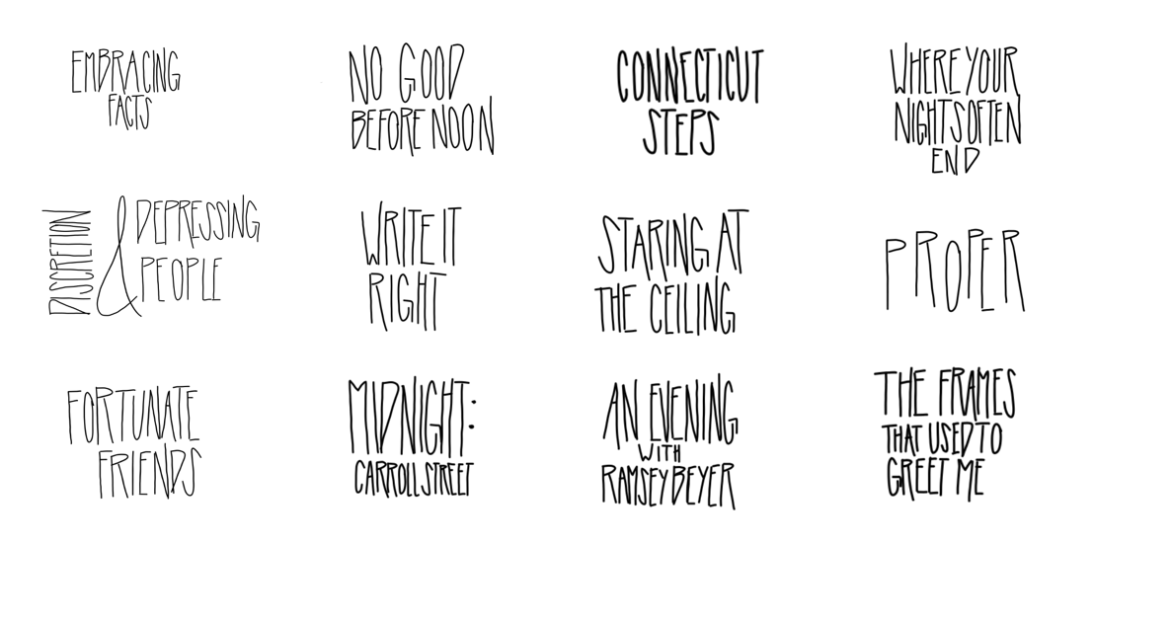



*I don’t have all that much to say about this one, I’ll be honest, but I’m a sucker for some temperature based language! The parallel of a city getting colder then warming up with skipping forward to a better place is poignant. It’s something I can feel.*

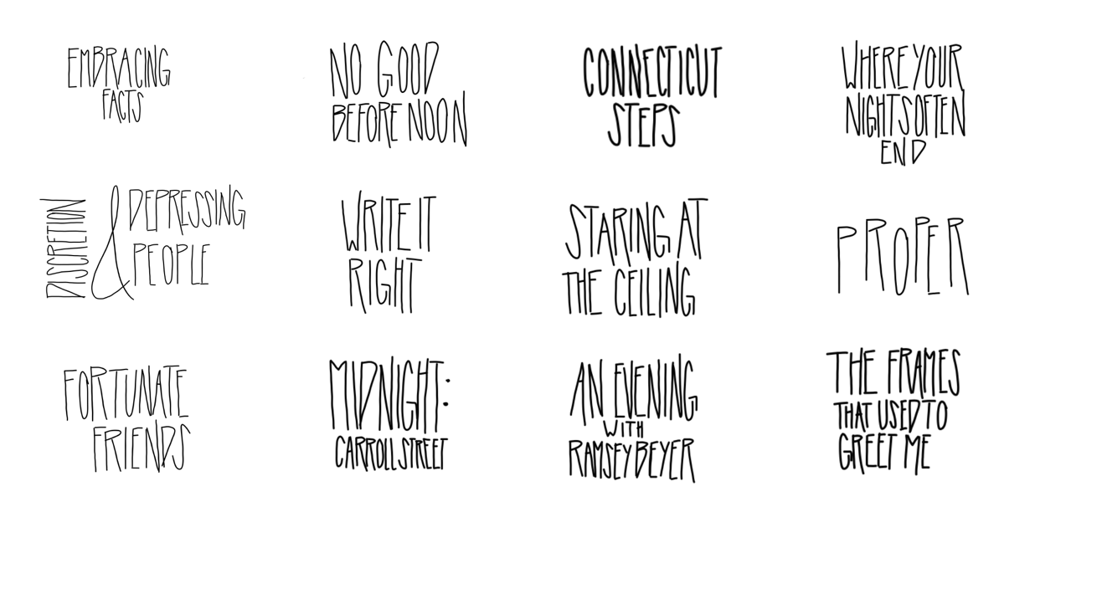

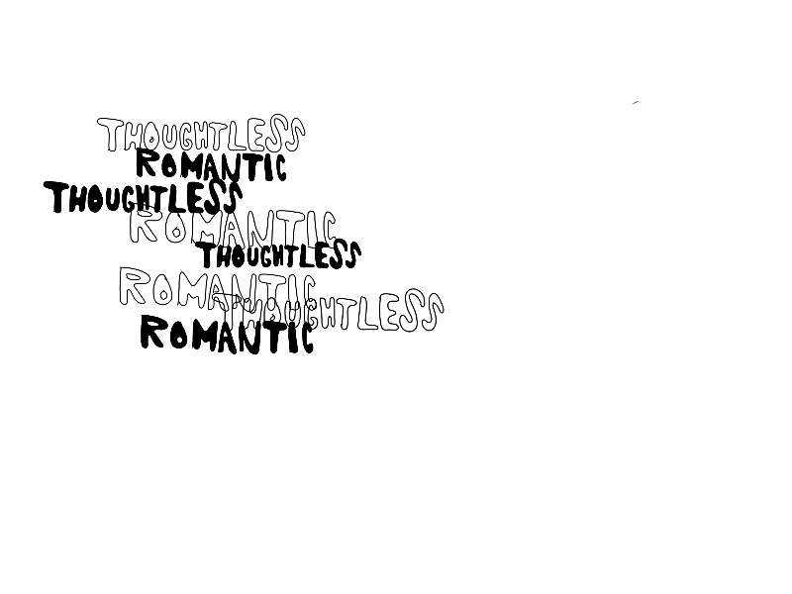

*Where Your Nights Often End was another song that made it on any playlist I made in high school. The look inside a moment is achieved perfectly here. Barstools and discount beer. Lonely surrounded by friends. I’ve always specifically been drawn to the phrasing of “thoughtless romantic” and how that turn of phrase twists the knife of something inside me. For some reason this song reminds me of Wicker Park (the song, not the place) and I listen to them paired together often. They both feel hollow in a nice way.*

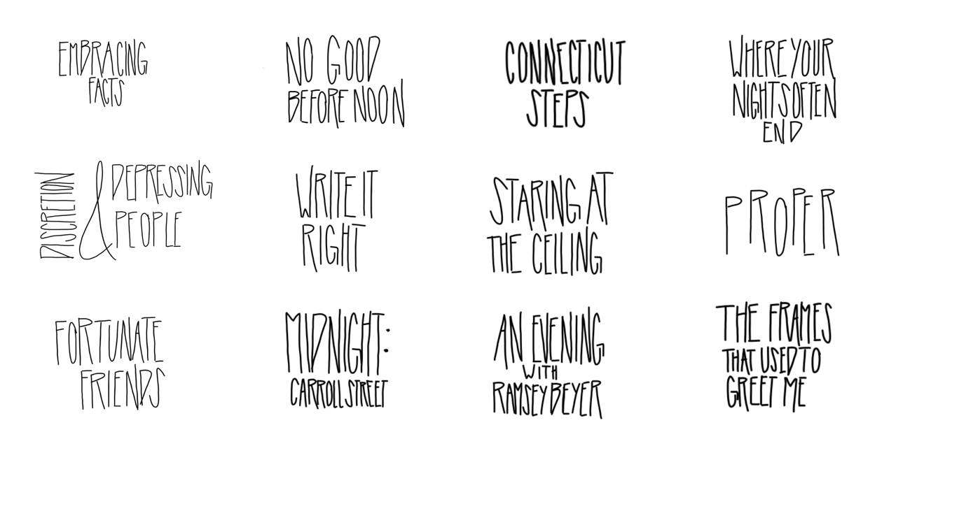

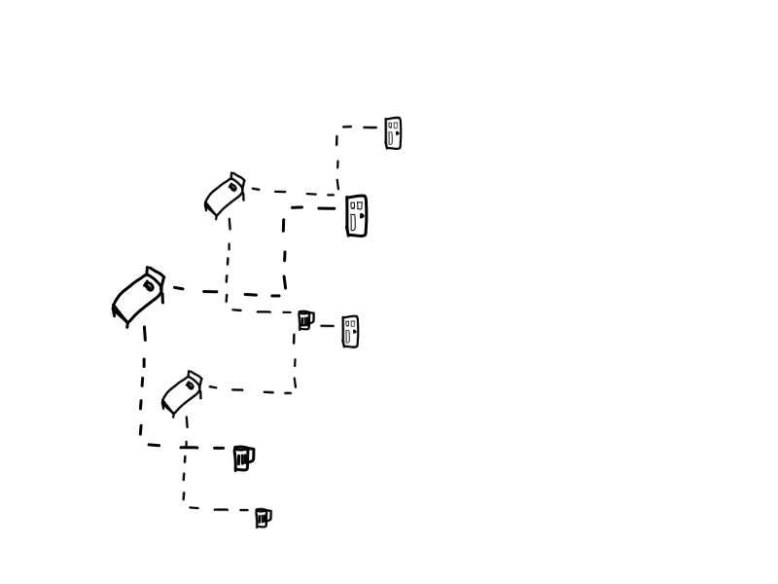

*The best thing about this song to me is the payoff of major themes in the album. Confronting going out rather than staying in on the couch. Recognition of self-help and looking back at yourself. Finally having courage to go talk to someone you’ve been putting off talking to. I don’t know that this album has a super strong overall narrative, but there is continuous themes and this one ties those together nicely.*

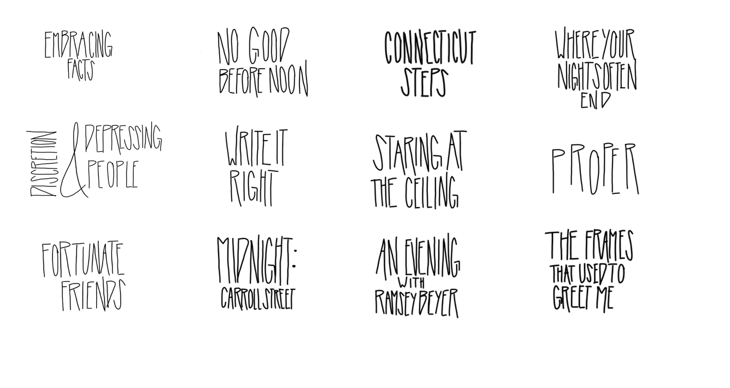

*The final track feels like closure to me. Closure of the inside vs. outside theme throughout the album. Public anger vs. private anxieties. Nights spent at home vs. nights spent at a bar. The necessary comfort that is communicated through someone letting themselves out and the way the song makes that loss felt. Inevitable and necessary end.*

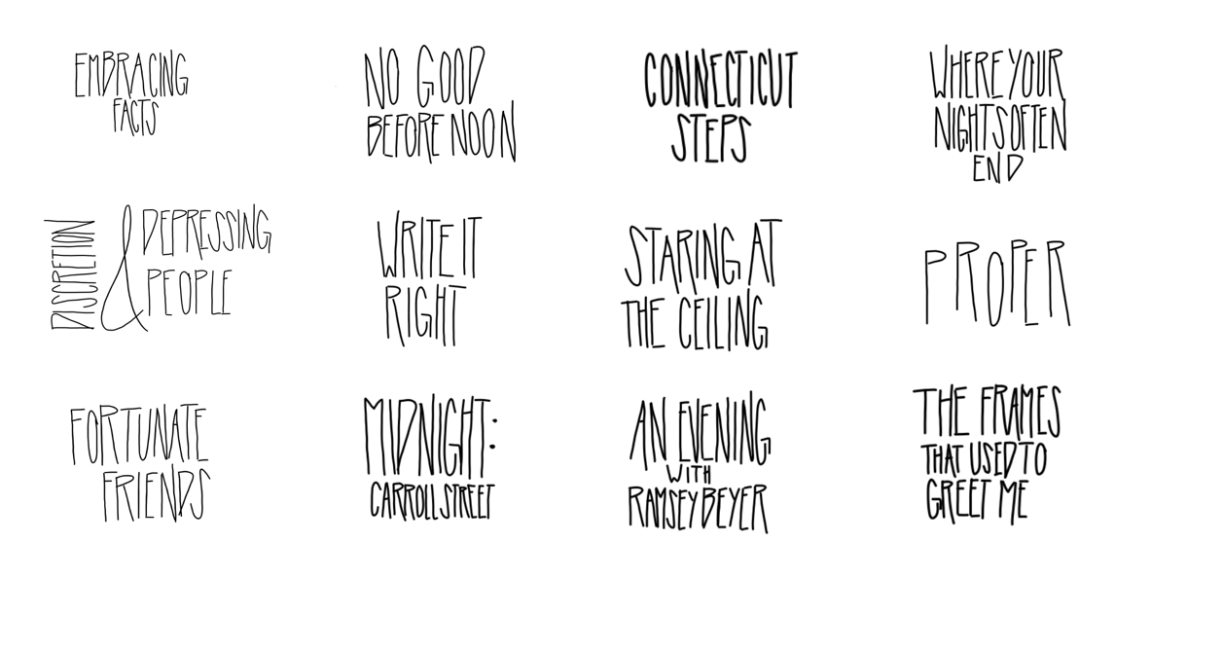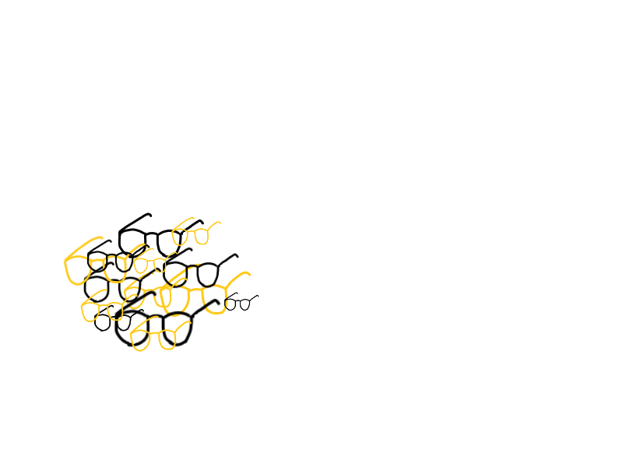

*Into It. Over It. is a band I love so much because it feels like Chicago. I went to the Proper anniversary show alone and it’s the best I’ve ever felt alone at a show. The familiarity of the music, all of it, even the stuff Evan doesn’t know how to play anymore, is why I return to it over and over again.*

*It’s Chicago in October. It’s a friend saying they biked to meet you and it’s colder than they thought. It’s picking up the Reader every Thursday. It’s the brown line to Kimball. It’s the warmth of familiarity.*

*this zine was written and illustrated by miranda reinert.*

*thank you.*

whp1